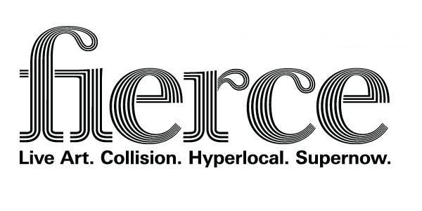
FIERCE 2014 - Volunteer Application Form
Name:
Address:
Post code:
Email:
Telephone:
Mobile:
Date of Birth:
Male/Female (please circle)
Are you…(please tick the relevant box)
Student ☐ Graduate ☐ Unemployed ☐
P/T Employed ☐ F/T Employed ☐ Retired ☐

Tell us about yourself and why you want to volunteer for Fierce? (max. 100 words)

[type here]

What artist or artistic experience has inspired or excited you in the last 12 months…(max. 100 words)
[type here]

AVAILABILITY
We ask our volunteers to do a minimum of four shifts with varying roles across the festival.
This year we will need volunteers between Tues 30 September to begin the Get In at some events, until 15 October, as well as across the main festival weekend .
Shifts will be between 4 - 6 hours depending on the nature of the event.
There will be a sign up sheet at the volunteers briefing with more detail regarding shifts against the programme however if would be useful if you could note your availability below (available/not available ) so that we can begin to get an idea of capacity that would be great:
Date | AM | PM | EVENING
30 Tues Oct
1 Weds Oct
2 Thu Oct
3 Fri Oct
4 Sat Oct
5 Sun Oct
6 Mon Oct
7 Tue Oct
8 Wed Oct
9 Thur Oct
10 Fri Oct
11 Sat Oct
12 Sun Oct
13 Mon Oct
14 Tue Oct
15 Weds Oct

Please email completed applications forms to Sarah Hamilton Baker at Volunteers@wearefierce.org by 5pm, Thursday 5 September 2013.
Please note the volunteers briefing meeting will take place on Mon 9 September in Digbeth.

